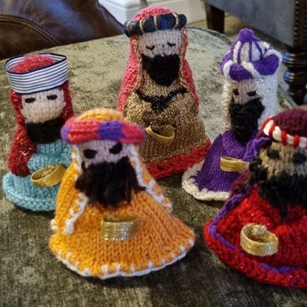
WISE MAN. Bringing GOLD
You will need Double knitting wool Bright colours, Reds, Emerald green, Golds, Purples ETC
Knitting needles 3.25 or 4mm (8-9 or 10)
With your bright robe wool cast on 48 sts. knit one row.
Next rows Knit row & pearl row.
K2 tog, k10 repeat until end of row. Knit row & Purl one row.
K2tog K9 Repeat until end of row . Purl one row ,Knit one row
K2tog K8 Repeat until end of row . Knit one row ,Purl one row
K2tog K7 Repeat until end of row . Purl one row ,Knit one row
K2tog K6 Repeat until end of row . Knit one row ,Purl one row
K2tog K5 Repeat until end of row . Purl one row ,Knit one row
K2tog K4 Repeat until end of row . Knit one row ,Purl one row
You should have 20 stitches left.
Purl & Knit 6 more rows then change to face colour for the head.
Purl one Row Knit one row 4 more times.
Knit 2 tog Repeat until the end.
Purl one row Knit one row.
Purl 2tog until the end of the row and draw wool through to gather up the head and turn inside out and stitch up head & body.
HEADDRESS. In any colour you like cast on 20 stitches.
Using K&P rows work at least 7 rows, if you want a longer headdress add as many rows as you like then, using alternative Knit /Purl rows decrease at each end by knitting 2tog at each end. Continue until you have 8 stitches left. Work 2 rows and cast off.
Sewing the headdress on to the head beginning at the front sew it along the head then sew the sides down the face.
ARMS. Using matching dress wool cast on 20sts and work 6 rows. Cast off and stitch up making a long tube. Attach each side onto the dress and gather in the middle.
CROWN. These can be made just like the arms , you can mix the colours, add contrasting wool and wrap it around the tube , I have also used a piece of wide ribbon sewn it up ,stuffed some cotton wool into it and sewn it on as a headdress, adding some different wool wrapped around it, then stitch to the head over the headdress.
You can use ribbon ,glittery wool, Just make them your own. There isn’t a wrong way at all, the children will love them. If you have your own idea for a crown go for it !!!
These are the Wise men who bring Gold, so to in the middle of the hands add something Gold or yellow. I just used gold ribbon, I rolled it up and made a ring of the ribbon. You can knit a square of gold/yellow and stitch it to the hands, or crochet a round gold/yellow, cut a bit of yellow felt and sew that to the hands ,anything you can use which is safe for children is fine.
Once the King is all knitted and sewn up add a beard and eyes etc.
Thank you for taking the time to bring a smile to a child’s face. Bless you. Toni

